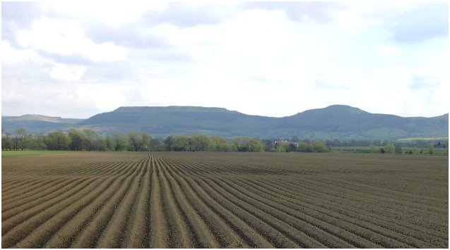
Sunday 22nd May 2016
Magna Broctun
North York Moors AC in Association with Great Broughton and Kirby Sports Club Great Broughton and Kirby 10K
and 2K fun run
INAUGURAL RUN OF THIS EVENT

North York Moors A C

Starts and finishes at the Great Broughton and Kirby Sports Club

(TS9 7HG inc parking)
(UKA licence number 2016-26279)

The race starts at 10.30am and uses the minor roads around Great Broughton and Kirby
The 2K fun run starts and finishes on the Sports Club field – Race starts at 10.00am
Prizes in all categories!

Entry Fee is £10 for the 10K race if affiliated or Sports Club member £12 otherwise, £14 on day

Enter via the following website www.sportentrysolutions.com
The 10K race is open to competitors of 15 years and older.
The 2K fun run is open to entries on the day. (Parents may accompany younger runners) Maximum age is 14 years.

- The course: The course is a nominal 10k and uses the minor roads between Great Broughton, Kirkby and Busby, starting and finishing at the Sports Club. It is well signed and marshalled. Caution is urged as the roads are open to traffic!

- The start: The start takes place at 10.30am in the Sport Club field.
- Information / Results: Further information can be obtained the North York Moors AC or Great Broughton and Kirby Sports Club website. After the event individual times / results will be published on those web sites. (www.nym.ac and www.broughton-kirby.com)

- Prizes: Prizes will be presented as soon as possible after the last runner crosses the line.

- Caution: Competitors take primary responsibility for their safety and participate in the event at their own risk. The organisers cannot accept any responsibility for personal accident or damage to athletic equipment and other personal effects or any public liability.
Prize for the first non-affiliated runner that lives in either Great Broughton or Kirkby
10K Prizes
Men | Prize | Women | Prize |  | Veterans
1st | 50 | 1st | 50 |  | Men | Prize | Women | Prize
2nd | 40 | 2nd | 40 |  | Over 45 | 1st £20 / 2nd 10 | Over 45 | 1st £20 / 2nd 10
3rd | 30 | 3rd | 30 |  | Over 55 | 1st £20 / 2nd 10 | Over 55 | 1st £20 / 2nd 10
 |  |  |  |  | Over 65 | 1st £20 / 2nd 10 | Over 65 | 1st £20 / 2nd 10
 |  |  |  |  | Only one prize per runner!

